- Log into Clever & click on the red “canvas” icon | 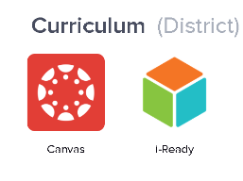
- Click into “English Language Arts-4 - Pascal” | 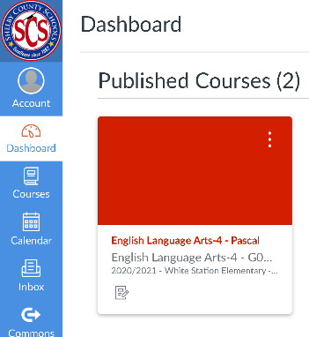
- Click on “Class Gather” & then “McGraw-Hill” | 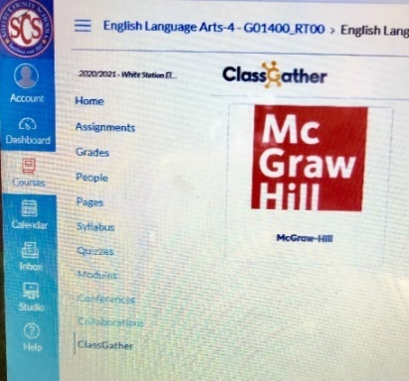
- Launch “Wonders Grade 4” | 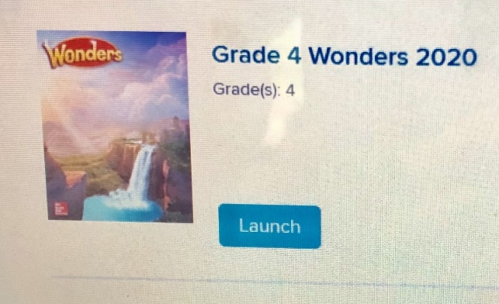
- This is the student dashboard | 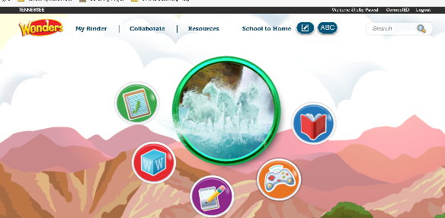
- Click on the “To Do” circle | 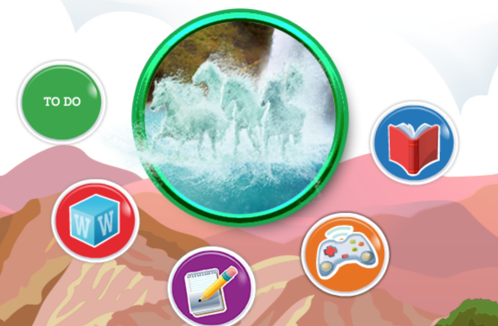
- Class Assignments & Homework will show in the student notebook.

